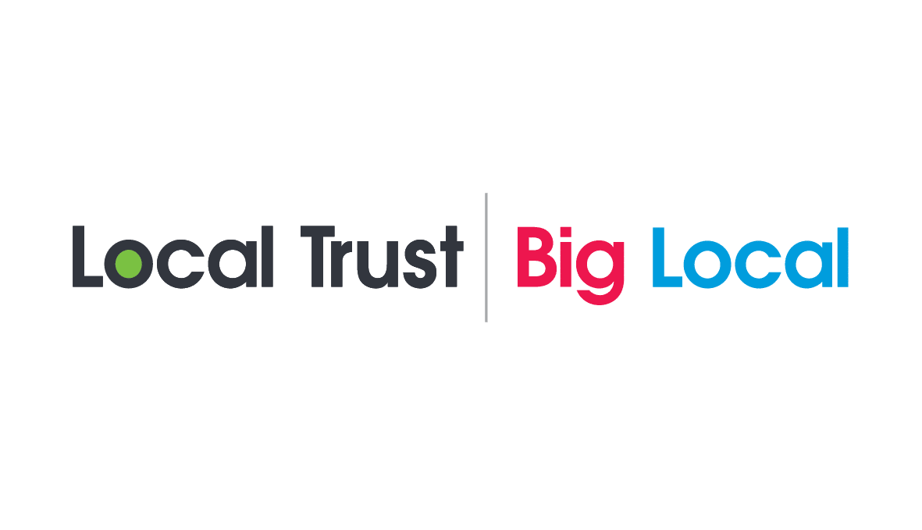
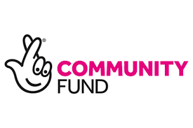

Distington Big Local

Transport Grant Application Form
Maximum Amount £500 to be used for transport only

SECTION 1 – ABOUT YOUR GROUP/ORGANISATION
Your Name
Name of Group/Organisation
Phone No.
Email address
Postal address

SECTION 2 – ABOUT YOUR PROPOSAL

Please tell us about what you would like to do and when you want to do it.

(Max 200 words)

SECTION 3 - WHO IS INVOLVED?

Who will benefit from this proposal?
Are they all from the Distington area?
Will you be working with any other group?
What difference will it make to local people?

SECTION 4 - THE COSTS

How much will the proposal cost?
How much are you asking DBL for?
What will the money be spent on?
If additional funding is required, where is it coming from?

SECTION 5 - IS THERE ANYTHING ELSE YOU WOULD LIKE TO TELL US?

SECTION 6 – DECLARATION

- I am authorised to make this application on behalf of this group or organisation
- I certify that the information contained in this application is true and correct
- If the information changes in any way, I will notify Distington Big Local immediately
- I give permission for Distington Big Local to record the information in this application electronically and to contact the organisation by telephone, post or e-mail to discuss its activities or funding opportunities
- The organisation will only use the grant for the reason given in this application. If it is used for anything else, Distington Big Local may ask the group or organisation to repay it, and may want to see your accounting records. I acknowledge that the group or organisation will also have to repay any money we don’t spend.
- I understand that the Distington Big Local Partnership’s decision is final.

I understand that we are required to report back on the way the grant has been used and its impact.

Signature: ……………………………………………………………..……..

Full Name: …………………………………………………………..………..

Position in Group: …………………………………………………………….………..

Date: …………………………………………………………………………..

Please send your completed Application Form and supporting documents to:

FAO either Katie Storey/Danielle Leigh/Christine Pattinson The Distington Big Local Partnership Office, Distington Community Centre, Church Road, Distington CA14 5TE

Or e-mail to: katie.biglocal@gmail.com or daniellel.biglocal@gmail.com
Or hand them in person to: Christine Pattinson

Have you remembered to include the following documents in support of your application?

A copy of your Constitution or Terms of Reference

A copy of your last set of Accounts, or your latest Bank Statement if applicable.

A copy of your safeguarding policy if working with young people or vulnerable

adults

N.B Supporting documents are needed for all applications.

Office use only
Date Received:
Acknowledged on:
Panel Date:
Panel Outcome:
Signed by Chair:
Applicant notified

